BOOK LAUNCH

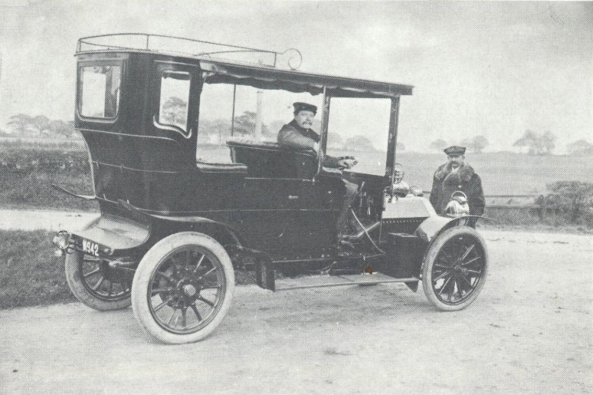
Image: R. G. A. Chesterman, Laughter in the House (Chester: Cheshire County Council, 1978), p. 31

THE CHESHIRE MOTOR VEHICLE REGISTRATIONS, 1904-07
Edited by Craig Horner
Record Society of Lancashire and Cheshire, volume 156
The Cheshire vehicle registrations are amongst the few complete collections in the country for the period up to the First World War. This edited transcript of the records, for the period 1904 to 1907, allows a glimpse of the variety of motor cars, motor-cycles and ‘lurries’ then on the Cheshire roads. We can also identify successive registered owners and their addresses as the vehicles passed down (and sometimes up) the social chain. Additionally, the occupations and dates of birth of these owners have been incorporated. This volume is the first in a set to cover the entire period to 1914.
To celebrate the publication of this volume, the Record Society of Lancashire and Cheshire are holding a launch:

Date: Monday 27 January 2020
Time: 6.30-8.00pm (formalities to begin at 7.00pm)
Venue: 70 Oxford St (formerly ‘The Cornerhouse’),
Manchester Metropolitan University, Manchester, M1 5NH

The event will include a talk by the author, and an opportunity to purchase the volume at a special price.
ALL WELCOME!

